Procedure to install and run terraform

1. Install **Visual Studio Code**
2. Download Terraform.exe from Official website (<https://www.terraform.io/downloads.html>). Choose Windows and then download.
3. Create New folder in the name of Terraform in C:\ and copy and paste the already downloaded Terraform.exe in it.
4. Go the **Controlpanel**🡪**System**🡪**System** **Setting**(Left Panel)🡪**Advance**🡪**Click** **Environment** **Variables**🡪**select** “**path**”🡪**Edit**🡪**Browse**-->Choose the folder created in **Step 3**.
5. Do you use Terraform in VS code, you need to [install Node.js](https://nodejs.org/)
6. Launch VS code and install following Extenstions
   1. Azure Terraform
   2. Terraform

### Prepare a test plan file

1. In Visual Studio Code, select **File > New File** from the menu bar and copy and paste the below code for creating resource group and choose the location and save the file as .tf extension.
2. resource "azurerm_resource_group" "test" {
3. name **=** "testResourceGroup1"
4. location **=** "West US"

2. Enter **Ctrl+shift+P** and select Azure **Terraform:init** command. It will initialize the terraform and popup appears and click OK.

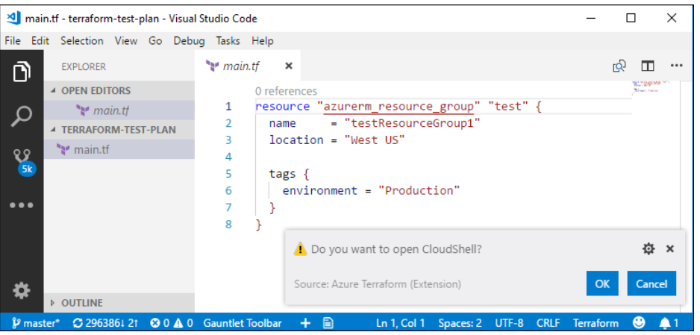

The first time you launch Cloud Shell from a new folder, you will be asked to set up the web application. Select **Open**.

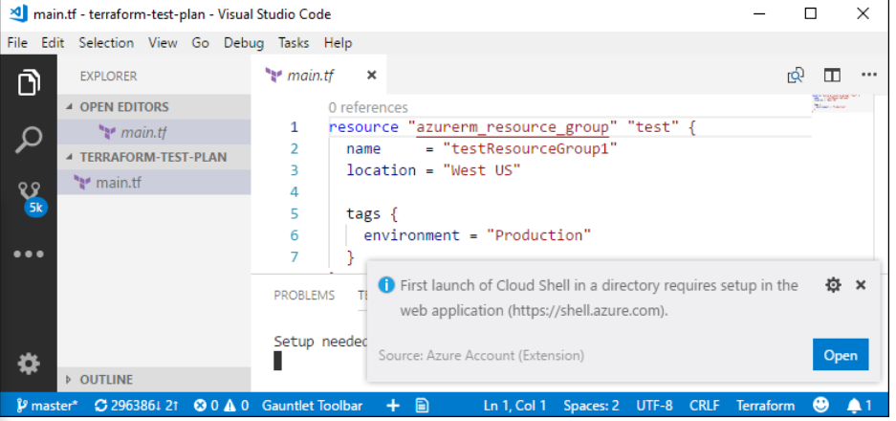

The Welcome to Azure Cloud Shell page opens. Select Bash or PowerShell.

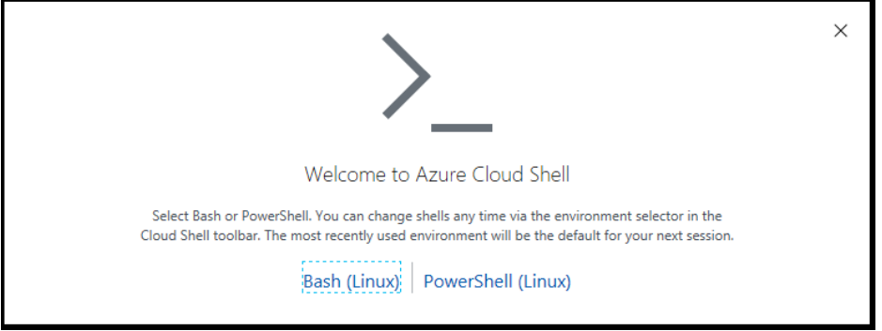

If you have not already set up an Azure storage account, the following screen appears. Select **Create storage**.

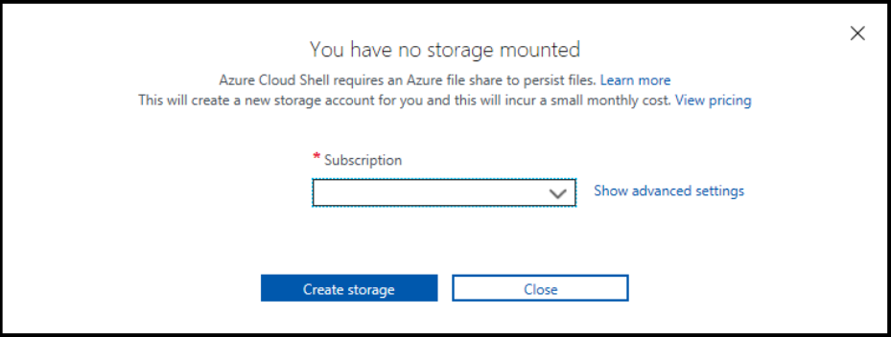

Azure Cloud Shell launches in the shell you previously selected and displays information for the cloud drive it just created for you.

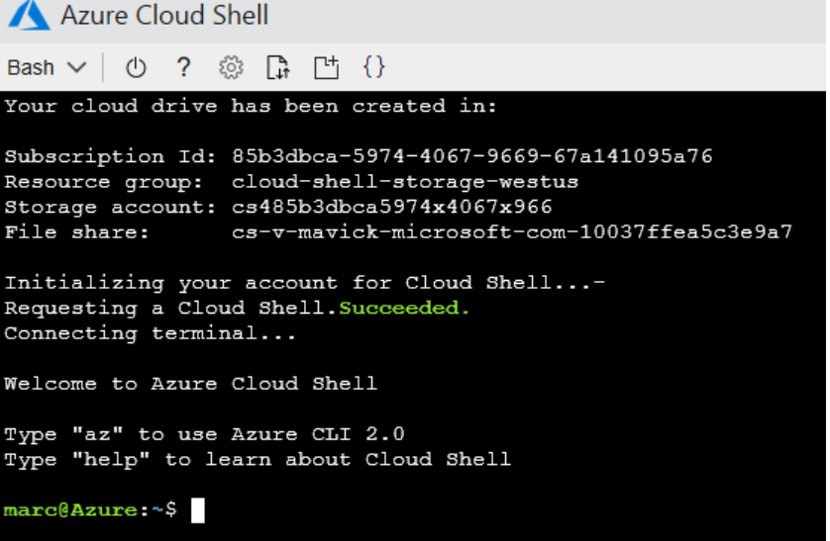

* You may now exit the Cloud Shell
* From the menu bar, select **View** > **Command Palette** > **Azure Terraform: init**.
* After Initialize successfully then execute the code Ctlr+Shift+P 🡪select Azure Terraform: apply
* Enter Yes
* Resource Group will be created successfully in the Azure.

Additional Terraform exe:

Based on the providers and resources, there may be a requirement to add additional terraform executable files that are available in the official website. To add them follow the below steps

1. In C:/ search for “**terraform.d**” folder.
2. Create a new folder named “**plugins**”.
3. Inside plugins folder create a sub folder “**windows_amd64**”.
4. Place all the additional executable files download in the above folder.

